Why is USG rewriting the history of the mRNA vaccines?
Inbox

Robert W Malone MD from "Who is Robert Malone" <rwmalonemd@substack.com> Unsubscribe
12:39 PM (2 hours ago)

from: Robert W Malone MD from "Who is Robert Malone" <rwmalonemd@substack.com>
reply-to: Robert W Malone MD from Who is Robert Malone <reply+12537p&doii8&&cce8c37da4efd184c6fca58fd90d0a0927be4fd8b53dd682dc984e93bfd7819d@mg1.substack.com>
to: fchase@gmail.com
date: Jul 14, 2022, 12:39 PM
subject: Why is USG rewriting the history of the mRNA vaccines?
mailing list: rwmalonemd@substack.com Filter messages from this mailing list
mailed-by: mg2.substack.com
signed-by: mg2.substack.com

Open in browser
Subscribe now

Why is USG rewriting the history of the mRNA vaccines?
State-sponsored media and the US Government is erasing the inventors from history

Robert W Malone MD, MS
Jul 14

Comment
Share

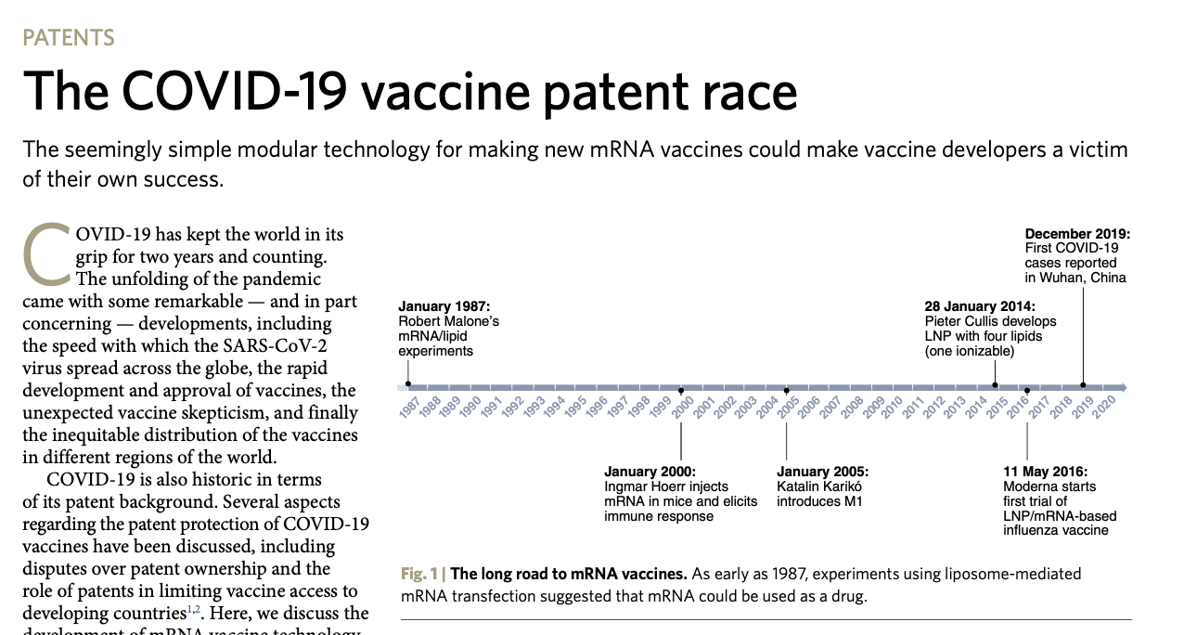

Authored by: Jill Glasspool Malone, PhD
Nature Biotechnology published a paper in July, 2022 called “The COVID-19 vaccine patent race.” In this paper, Nature Biotechnology asserts that the first reduction to practice of mRNA vaccination occurred in 2000. This is patently false. It is hard to believe that this could be an accidental oversight by this scientific journal. The first in-vivo (animal) experiments reducing this mRNA vaccination to practice occurred in 1989. The first experiment was mRNA Vaccination of Mice to Produce the gp120 Protein of HIV Virus with subsequent production of gp120 antibody in the mRNA vaccinated mice, and the second experiment was mRNA Vaccination of Human Stem Cell-Bearing SCID Mice with HIV nef mRNA Followed by HIV Challenge. Both experiments were presented to the United States Patent Office and these claims were approved in nine issued patents, all with a priority date of March 21, 1989. That means that these experiments were conducted in 1989-90. These two examples and the nine patents are listed at the end of this article. Note that these patents also include extensive descriptions of the technology.
This is not the first time that the Nature journals failed to properly cite and acknowledge the early work of Dr. Malone and his other co-inventors listed on the patents as the actual inventors of the mRNA vaccine platform and technologies. In September, 2021, Nature published an article, written by Eli Dolgin that asserts that the first proof of principle experiments occurred much later in 2005. That paper was never corrected, even though Dr. Malone notified the author, Eli Dolgin about the error. Mr. Dolgin refused to even read the patents and to consider that fact that the timeline listed in that paper was incorrect. This has set up a cascade of major newspapers, journals and magazines insisting that Dr. Malone has nothing to do with the actual proof of principle mRNA vaccine experiments.
The Congressional Research Services (CRS) then put out a book for Congress entitled: "mRNA Technologies: A Primer", published in May 2022. This is the government record on the history of mRNA vaccination and technologies. Again, the invention and timeline (the CRS taken from the Nature article above) is not just wrong, it is glaringly false. When the CRS was contacted, they refused to engage and correct their publication, a screen shot of the CRS reply is here:
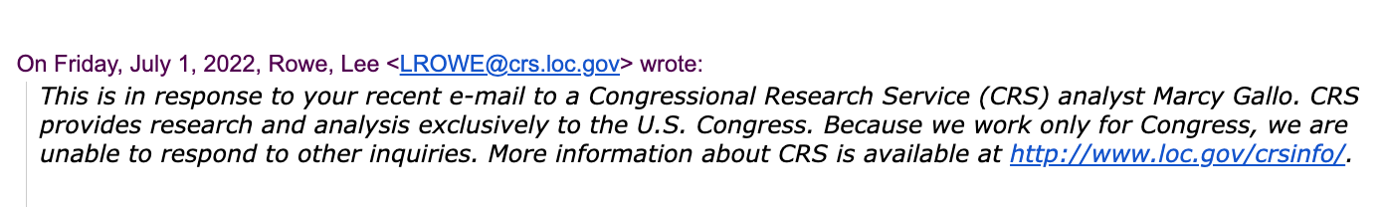
The question has to be why? What is going on? The patent record is quite clear, as adjudicated by the US Patent and Trademark Office, the official government agency responsible for adjudicating and assigning inventorship. Is this merely a case of incompetent oversight and editing of a Congressional Research Service publication, or should more meaning be placed on this false time line? On the government choosing to remove the true inventors of mRNA vaccines from the congressional record? Is this as it appears? Is the government literally trying to erase the role that Dr. Robert Malone had in this invention, and write him, his work, and that of his co-inventors out of history?
Here [below] is the CRS fabricated version of the invention. Note that the first proof of principle experiments, as documented and published by the USPTO are missing from this figure found in the CRS document.
The CRS completely wrote out the seminal proof of principle experiments as documented in the figure from their publication below. This is now the Congressional record - the US GOVERNMENT’S RECORD OF EVENTS!
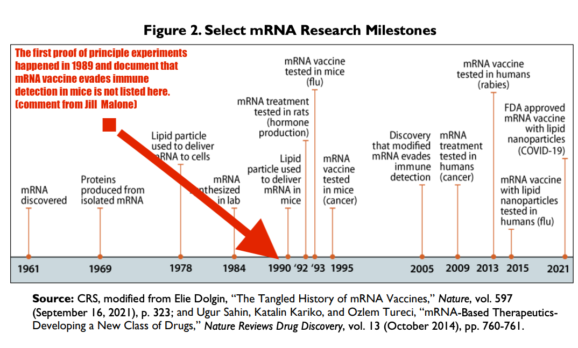
So what is the correct history?
The history of the mRNA vaccines all started when Dr. Robert Malone was at the Salk Institute in 1987 and 1988 as a graduate student. There, he pioneered in-vitro RNA transfection and also in-vivo RNA transfection (in frog embryos, as well as mice).
This resulted in his seminal paper: Cationic liposome-mediated RNA transfection RW Malone, PL Felgner, IM Verma. Proceedings of the National Academy of Sciences (PNAS) 86 (16), 6077-6081
The Science paper was the first showing data for DNA and RNA side by side for in-vivo (the first paper for in-vivo DNA). That paper was published in 1990.
Direct gene transfer into mouse muscle in vivo. Wolff JA, Malone RW, et al. Science. 1990;247(4949 Pt 1):1465-8. Cited in 4,750 articles, is the result of that work.
Dr. Malone filed patent and disclosures from the Salk included in-vivo RNA transfection and also methods for mRNA stabilization - now being claimed as invented by others. These are available for review on his website.
His research was continued at Vical in 1989, where the first in-vivo mammalian rat experiments were designed by him. The mRNA, constructs, reagents were developed at the Salk institute and at Vical by Dr. Malone, this included dosing amounts for the in-vivo experiments. RNA and DNA were sent to Dr. Jon Wolff via Fedex. Dr.Wolff at the University of Wisconsin injected mice and rats. The initial patent disclosures for RNA and DNA vaccination were written by Dr. Malone in 1988-1989 – those are also on his website.
This body of work resulted in over 9 patents and numerous publications, yielding about 7000 citations of this patented work.
In 1989, research was performed that gave rise to the 9 groundbreaking patents on mRNA vaccination and transfection, all with a priority date of March 21, 1989. This is the same priority date as the Salk Patent application, showing that the lawyers from the two institutions were working together. These patents are the first published research on mRNA vaccination. The titles and links to the patents are listed in the documents below. These patents have proof of principle experiments on mRNA vaccines - that clearly document that the invention worked and that these are the first experiments showing this.
Clearly the inconvenient history is something that the government, big pharma, newspapers and even journals like Nature do not wish to have public know the full history. But what the most recent Nature Biotechnology report has written is shockingly inaccurate and this is not the first time the Nature journals have falsified who invented these vaccines.
The first mRNA experiments in which the discoveries and ideas were reduced to practice in a mammal- as presented in the actual issued and published patents- are linked below.
Following is the text of the proof of principle experiments (example 8 and 9) from the nine issued patents! A full description of the invention is also included the patents. As Dr. Malone invented this technology, wrote the patent disclosures, led and was involved in those early experiments. Once he left Vical, he continued to collaborate with Dr. Gary Rhodes on these technologies. So, what the US government, Nature and various newspapers, journals and magazines now write as the history is an untruth. These patents also have four other inventors – who contributed to the experiments. But the actual invention and the idea came from Dr. Malone, who has extensive documentation to this effect. For a detailed history, written by Dr. Jill Malone – click here.
As an aside, a decision was made by the owners of the patent, a corporation called Vical, that this work, these proof of principle experiments were not to be published. Instead Vical licensed the technology to Merck, who then abandoned the mRNA technology, and tried to develop the DNA vaccines without much success. The inventors were never able to publish their work or even speak about it without Vical’s permission, as they were under employment agreements – even after they left the employment of Vical.
Here are two of the first experiments - as written in the patents - priority date 1989.
EXAMPLE 8: mRNA Vaccination of Mice to Produce the gp120Protein of HIV Virus
A liposomal formulation containing mRNA coding for the gp120 protein of the HIV virus is prepared according to Examples 1 through 5, except that the gene for gp120 (pIIIenv3-1 from the Aids Research and Reagent Program, National Institute of Allergy and Infectious Disease, Rockville, Md. 20852) is inserted into the plasmid pXBG in the procedure of Example 4. A volume of 200 al of a formulation, prepared according to Example 6, and containing 200 μg/ml of gp120 mRNA and 500 μg/ml 1:1 DOTAP/PE in 10% sucrose is injected into the tail vein of mice 3 times in one day. At about 12 to 14 h after the last injection, a segment of muscle is removed from the injection site, and prepared as a cell lysate according to Example 7. The HIV specific protein gp120 is identified in the lysate also according to the procedures of Example 7.
The ability of gp120 antibody present in serum of the mRNA vaccinated mice to protect against HIV infection is determined by a HT4-6C plaque reduction assay, as follows: HT4-6C cells (CD4+ HeLa cells) are obtained from Dr. Bruce Chesebro, (Rocky Mountain National Lab, Montana) and grown in culture in RPMI media (BRL, Gaithersburg, Md.). The group of cells is then divided into batches. Some of the batches are infected with HIV by adding approximately 105 to 106 infectious units of HIV to approximately 107 HT4-6C cells. Other batches are tested for the protective effect of gp120 immune serum against HIV infection by adding both the HIV and approximately 50 μl of serum from a mouse vaccinated with gp120 mRNA. After 3 days of incubation, the cells of all batches are washed, fixed and stained with crystal violet, and the number of plaques counted. The protective effect of gp120 immune serum is determined as the reduction in the number of plaques in the batches of cells treated with both gp120 mRNA-vaccinated mouse serum and HIV compared to the number in batches treated with HIV alone.
EXAMPLE 9: mRNA Vaccination of Human Stem Cell-Bearing SCID Mice with nef mRNA Followed by HIV Challenge
Severe combined immunodeficient mice (SCID mice (Molecular Biology Institute, (MBI), La Jolla, Calif. 92037)) were reconstituted with adult human peripheral blood lymphocytes by injection into the peritoneal cavity according to the method of Mosier (Mosier et al., Nature 335:256 (1988)). Intraperitoneal injection of 400 to 4000 infectious units of HIV-1 was then performed. The mice were maintained in a P3 level animal containment facility in sealed glove boxes.
MRNA coding for the nef protein if [of] HIV was prepared by obtaining the nef gene in the form of a plasmid (pGM92, from the NIAID, Rockville, Md. 20852); removing the nef gene from the plasmid; inserting the nef gene in the pXBG plasmid for transcription; and purifying the transcription product nef mRNA as described in Examples 2 through 5. The nef mRNA was then incorporated into a formulation according to Example 6. 200 microliter tail vein injections of a 10% sucrose solution containing 200 μg/ml NEF RNA and 500 μg/ml 1:1 DOTAP:DOPE (in RNA/liposome complex form) were performed daily on experimental animals, while control animals were likewise injected with RNA/liposome complexes containing 200 μg/ml yeast tRNA and 500 μg/ml 1:1 DOTAP/DOPE liposomes. At 2, 4 and 8 weeks post injection, biopsy specimens were obtained from injected lymphoid organs and prepared for immunohistochemistry. At the same time points, blood samples were obtained and assayed for p24 levels by means of an ELISA kit (Abbott Labs, Chicago, Ill.) and virus titer by the plaque assay of Example 8. Immunostaining for HIV-1 was performed as described (Namikawa et al., Science 242:1684 (1988)) using polyclonal serum from a HIV infected patient. Positive cells were counted and the number of infected cells per high power field (400×) were determined. Using these assays, at least a 2 fold reduction in the number of positive staining cells was observed at 8 weeks, and titer and p24 expression was reduced by at least 50%. Together, these results indicate a moderate anti-viral effect of the (in vivo) treatment. A volume of 200 μl of the formulation, containing 200 μg/ml of nef mRNA, and 500 μg/ml 1:1 DOTAP:DOPE in 10% sucrose is injected into the tail vein of the human stem cell-containing SCID mice 3 times in one day. Following immunization, the mice are challenged by infection with an effective dose of HIV virus. Samples of blood are periodically withdrawn from the tail vein and monitored for production of the characteristic HIV protein p24 by an ELISA kit assay (Abbott Labs, Chicago, Ill.).
Below are the nine issued patents:
- Lipid-mediated polynucleotide administration to deliver a biologically active peptide and to induce a cellular immune response (includes mRNA). P Felgner, JA Wolff, GH Rhodes, R Malone, D Carson. Assigned to Vical, Inc and licensed to Merck. No. 7,250,404, date of issue: 7/31/07 Cited in 105 articles. Priority Date: 3/21/1989.
- Lipid-mediated polynucleotide administration to reduce likelihood of subject's becoming infected (includes mRNA). P Felgner, JA Wolff, GH Rhodes, Robert W Malone, D Carson. Assigned to Vical, Inc and licensed to Merck. US Pat. Ser. No. 6,867,195 B1. Date of issue: 3/15/05. Priority Date: 3/21/1989.
- Generation of an immune response to a pathogen (includes mRNA). P Felgner, JA Wolff, GH Rhodes, Robert W Malone, D Carson. Assigned to Vical, Inc and licensed to Merck. US Pat. Ser. No. 6,710,035. Date of issue: 3/23/04. Citations: 39 articles. Priority Date: 3/21/1989.
- Expression of exogenous polynucleotide sequences in a vertebrate, mammal, fish, bird or human (includes mRNA). P Felgner, JA Wolff, GH Rhodes, Robert W Malone, D Carson. Assigned to Vical, Inc, licensed to Merck. US Pat. Ser. No. 6,673,776. Date of issue: 1/6/04. Priority Date: 3/21/1989.
- Methods of delivering a physiologically active polypeptide to a mammal (includes mRNA). P Felgner, JA Wolff, GH Rhodes, Robert W Malone, D Carson. Assigned to Vical, Inc, licensed to Merck. US Pat. Ser. No. 6,413,942. Date of issue: 7/2/02. (cited in 150 articles). Priority Date: 3/21/1989.
- Induction of a protective immune response in a mammal by injecting a DNA sequence (includes mRNA). P Felgner, JA Wolff, GH Rhodes, Robert W Malone, D Carson. Assigned to Vical, licensed to Merck. US Pat. Ser. No. 6,214,804, date of issue: 4/10/01. Cited in 360 articles. Priority Date: 3/21/1989.
- Induction of a protective immune response in a mammal by injecting a DNA sequence (includes mRNA). P Felgner, JA Wolff, GH Rhodes, Robert W Malone, D Carson. Assigned to Vical, Inc, licensed to Merck. US Pat. Ser. No. 5,589,466. Date of issue: 12/31/96. Cited in 899 articles. Priority Date: 3/21/1989.
- Delivery of exogenous DNA sequences in a mammal (includes mRNA). Assigned to Vical, Inc, licensed to Merck. P Felgner, JA Wolff, GH Rhodes, Robert W Malone, D Carson. US Pat. Ser. No. 5,580,859. Date of issue: 12/3/96. Cited in 1244 articles. Priority Date: 3/21/1989.
- Generation of antibodies through lipid mediated DNA delivery (includes mRNA). P Felgner, JA Wolff, GH Rhodes, Robert W Malone, D Carson. Assigned to Vical, Inc, licensed to Merck. US Pat. Ser. No. 5,703,055. Date of issue: 12/30/97. Cited in 419 articles. Priority Date: 3/21/1989.
- A novel approach to study packaging of retroviral RNA by RNA transfection (Abstract). RW Malone, P. Felgner, I. Verma. RNA Tumor Viruses, May 17-18, 1988. Cold Spring Harbor (the first in a series of papers/abstracts on RNA transfection).
- mRNA Transfection of cultured eukaryotic cells and embryos using cationic liposomes. Malone RW. Focus. 1989; 11:61-8
- The SALK patent that was filed with the USPTO on 3/21/1989. Note that the cover letter hides this - and says it was filed on 3/29/89 - the sane date as all the VICAL patents, showing that there was collusion.
- THE VERY FIRST mRNA VACCINE EXPERIMENTAL DATA 1990 (from Vical to patent office)
- Cationic liposome-mediated RNA transfection. Malone RW, Felgner PL, Verma IM. Proc Natl Acad Sci (PNAS) U S A. 1989;86(16):6077-81. Cited in 749 articles.
- Direct gene transfer into mouse muscle in vivo. Wolff JA, Malone RW, et al. Science. 1990;247(4949 Pt 1):1465-8. Cited in 4,750 articles. Note that Robert was a student at Northwestern, and was never affiliated with University of Wisc.
- High levels of messenger RNA expression following cationic liposome mediated transfection tissue cultured cells. Malone R, Kumar R, Felgner P. NIH Conference: “Self-Cleaving RNA as an Anti-HIV Agent (abstract). Washington, DC June 1989.
- Cationic liposome-mediated RNA transfection. Dwarki VJ, Malone RW, Verma IM. Methods Enzymol. 1993;217:644-54. Cited in: 102 articles.
- Delivery of exogenous DNA (includes mRNA) sequences in a mammal P Felgner, JA Wolff, GH Rhodes, R Malone, D Carson. Biotechnology Advances 1993: 15 (3-4), 763-763
- DNA vaccines for eliciting a mucosal immune response (includes mRNA). US Pat. Ser. No. 6,110,898. Inventors: RW Malone and Jill Glasspool Malone. Date of issue: 8/29/00. Cited in 40 articles. Priority Date: 1996.
- Formulations and methods for generating active cytofectin: polynucleotide transfection complexes. Robert W Malone, et al. US Pat. Ser. No. 5,925,623 7/20/99.

